Help Documentation

Upon opening the app, there is a loading screen before the login page appears.

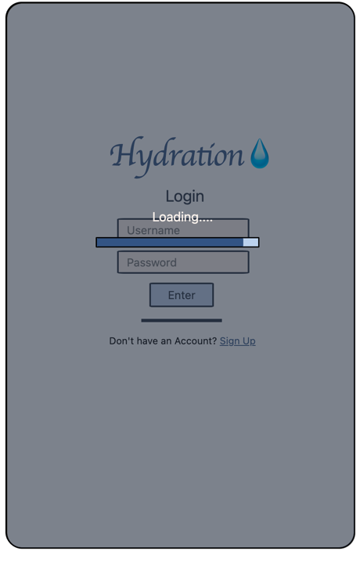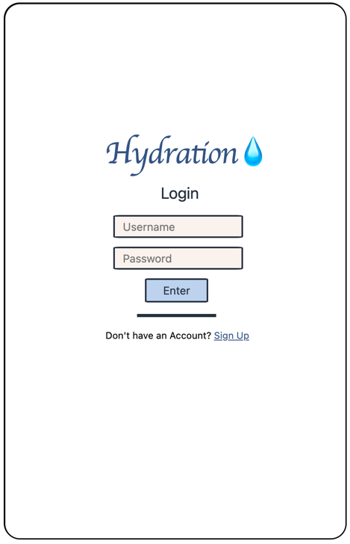

Loading page Login Page

In the input fields labelled “Username” and “Password”, you can input your existing login information before clicking “Enter” to access the app.

If the information is wrong, an error message will appear and information will have to be re-entered.

If you do not have an existing login, you can go to the sign up page by clicking the “Sign Up” hyperlink.

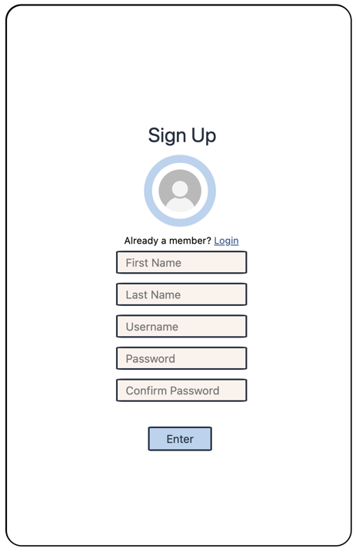

Sign Up page

Here you can input your information in order to sign up. If any fields are blank, the username already exists or the confirm password is not the same as the password an error message will appear. Otherwise, you will be signed up as well as logged into the app.

Once logged in, the home page will appear.

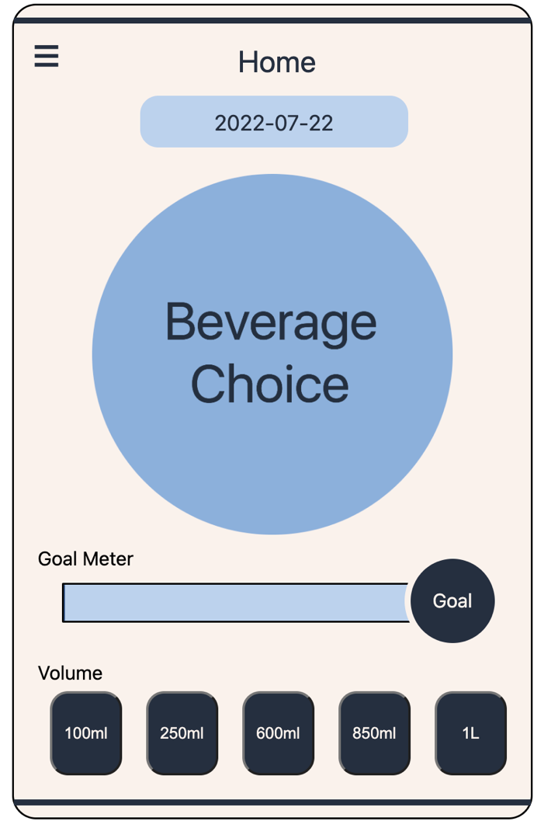

Home page

Here, you can input their beverage intake information in accordance to the date, as well as set your goal.

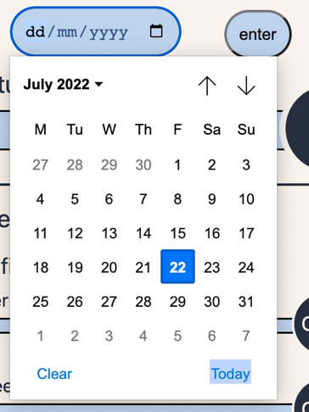

If needing to enter another date, you’re able to choose the corresponding date on the calendar. To access this just click on the date and then the little calendar button next to the ‘dd/mm/yyyy’. And to submit the date press the enter button. This will change and record the new date.

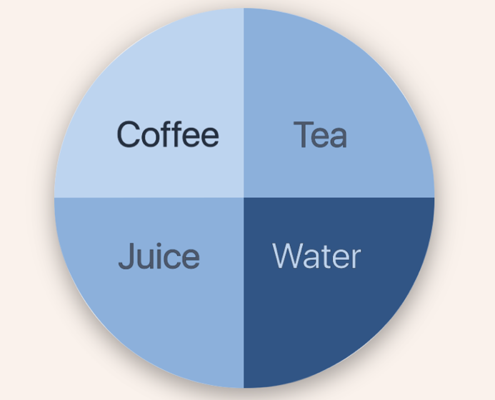

To choose your beverage intake type, you can click on the “Beverage choice” button to access the selection and choose your corresponding beverage.

Once chosen, the button will display the corresponding image to the beverage of choice.

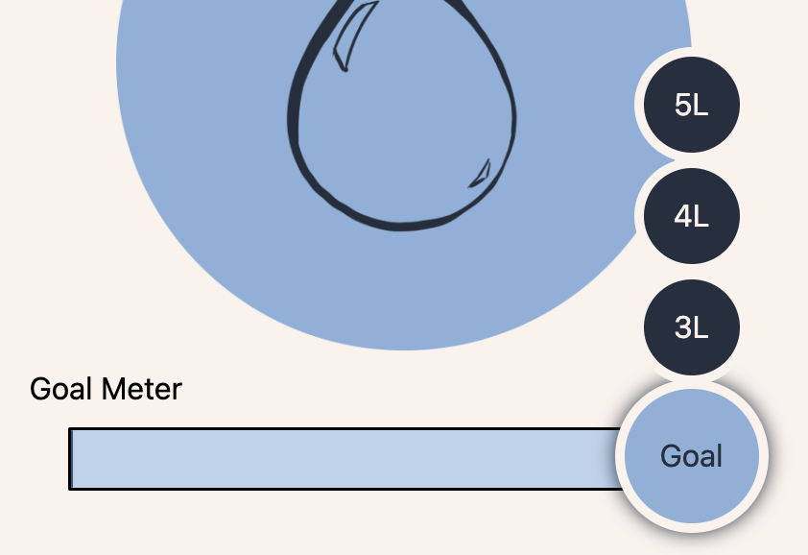

To set the goal, hovering over the “Goal” button will display a selection of goals to meet. Clicking on them will set the goal.

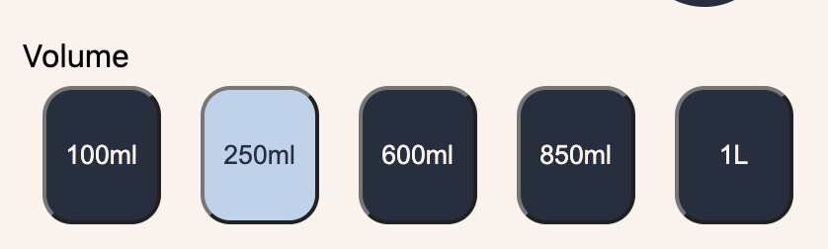

To enter the amount of beverage intake, you can then click on one of the set buttons for quick input of the amount of liquid drank. A loading screen will then appear and the data will be entered.

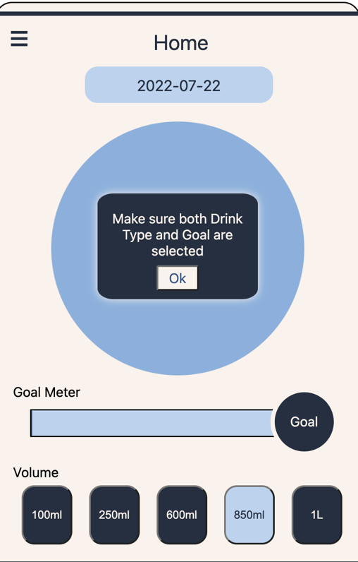

If you haven’t selected a drink or set a goal before clicking the beverage intake, you will be asked to do that first before entering the information.

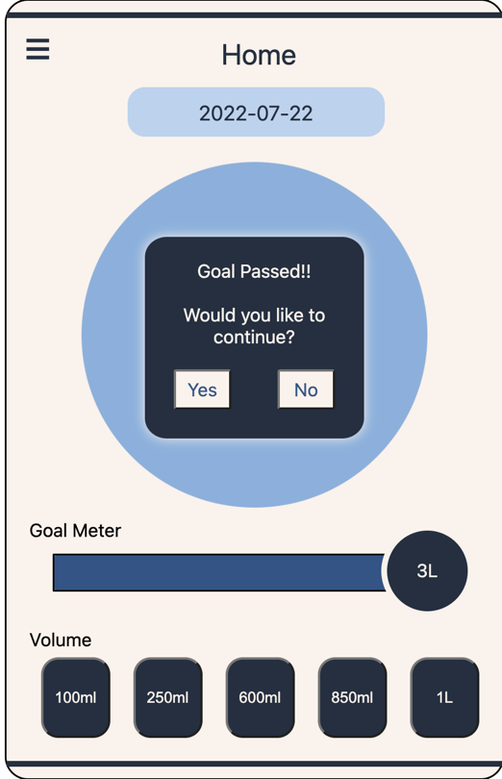

Each time you enter a beverage intake amount, the drink bar will go up and slowly reach the Goal. Once the goal is reached, it will notify you that your goal has been passed. Clicking yes will leave you on the Home page to add further information while clicking no will bring you to the statistics page.

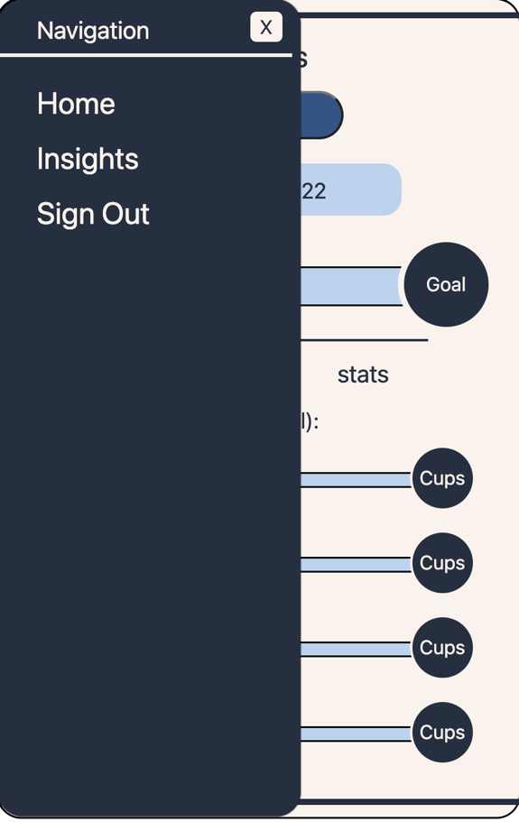

There is a navigation bar, to access it click the three lines on the top left corner of the screen. A bar will pop out with navigation options.

Clicking on “Home” will bring you to the home page. Clicking on “Insights” will bring you to the insights page. Clicking on “Sign Out” will sign you out and bring you back to the login page.

The insights page is to be used to access your statistics from the beverage input. Clicking on the date will once again allow you to reset your date if needed. Once the date is reset, click on the “Search” button will process the information for you.

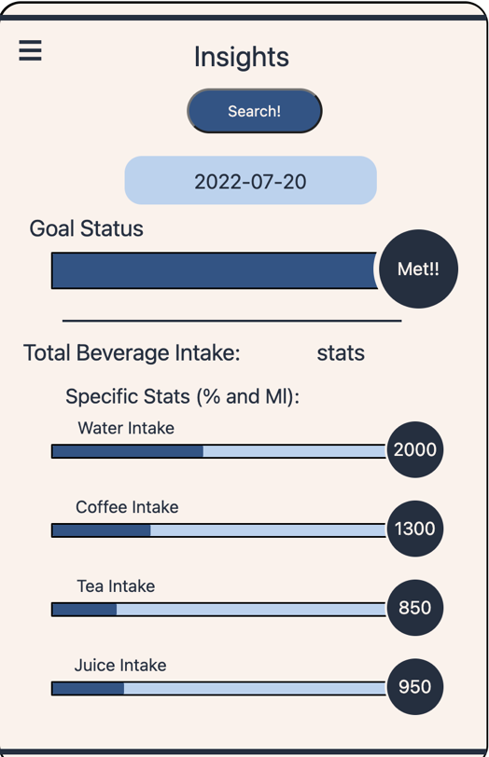

The insights will be displayed once the search button is clicked.

* “Goal Status” – shows you how much of your goal you have left to meet and whether you have met it or not.
* “stats” – will show you how many ML you have drank
* Each of the specific intake stats’ bars show you how much of that specific drink you have recorded out of the amount of total ML you have drank
* The numbers on each of the specific intake stats how you have many ML of that beverage you have drunk.